CSE 232 – HW2

Hasan Mutlu – 1801042673

**Question 1**

**a.1) F1 Function and Its Karnough Map**

F1(A, B, C, D) = ∑m(0, 1, 4, 5, 8, 9, 10, 12, 13)

F1 = A’B’C’D’ + A’B’C’D + A’BC’D’ + A’BC’D + AB’C’D’ + AB’C’D + AB’CD’ + ABC’D’ + ABC’D

**Karnaugh Map for F1:**

|  |  |  |  |  |
| --- | --- | --- | --- | --- |
| **CD**  **AB** | **00** | **01** | **11** | **10** |
| **00** | 1 | 1 | 0 | 0 |
| **01** | 1 | 1 | 0 | 0 |
| **11** | 1 | 1 | 0 | 0 |
| **10** | 1 | 1 | 0 | 1 |

* F1 = C’ + AB’D’

**a.2) Logic Circuit of F1**

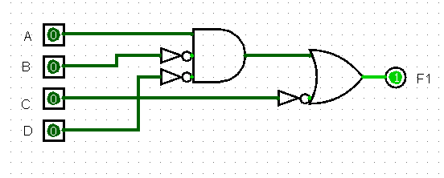

**a.3) Logic Circuit of F1 Using Only NAND Gates**

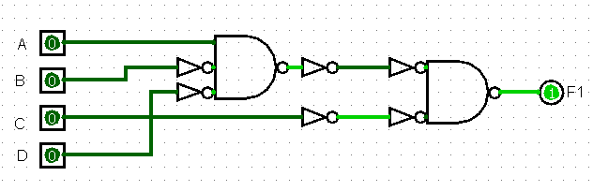

**b.1) F2 Function and Its Karnough Map**

F2(A, B, C, D) = ∑m(3, 5, 7, 8, 9, 10, 11, 13, 15)

F2 = A’B’CD + A’BC’D + A’BCD + AB’C’D’ + AB’C’D + AB’CD’ + AB’CD + ABC’D + ABCD

**Karnaugh Map for F2:**

|  |  |  |  |  |
| --- | --- | --- | --- | --- |
| **CD**  **AB** | **00** | **01** | **11** | **10** |
| **00** | 0 | 0 | 1 | 0 |
| **01** | 0 | 1 | 1 | 0 |
| **11** | 0 | 1 | 1 | 0 |
| **10** | 1 | 1 | 1 | 1 |

* F2 = AB’ + BD + CD

**b.2) Logic Circuit of F2**

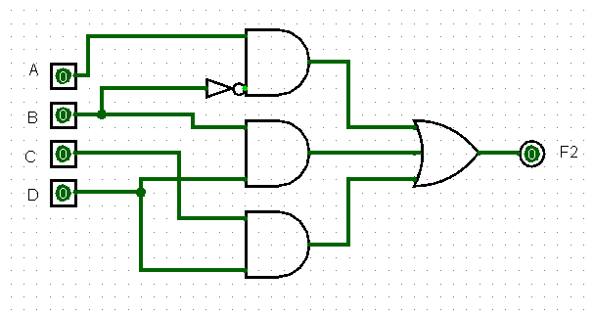

**b.3) Logic Circuit of F2 Using Only NAND Gates**

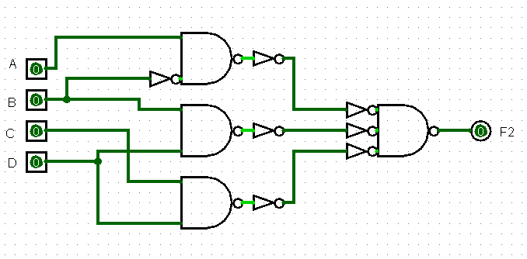

**Question 2**

**1.) F Function and Its Truth Table**

F = AB’ + AD + BC + CD’+ A’B’C’D’

|  |  |  |  |  |
| --- | --- | --- | --- | --- |
| A | B | C | D | F |
| 0 | 0 | 0 | 0 | 1 |
| 0 | 0 | 0 | 1 | 0 |
| 0 | 0 | 1 | 0 | 1 |
| 0 | 0 | 1 | 1 | 0 |
| 0 | 1 | 0 | 0 | 0 |
| 0 | 1 | 0 | 1 | 0 |
| 0 | 1 | 1 | 0 | 1 |
| 0 | 1 | 1 | 1 | 1 |
| 1 | 0 | 0 | 0 | 1 |
| 1 | 0 | 0 | 1 | 1 |
| 1 | 0 | 1 | 0 | 1 |
| 1 | 0 | 1 | 1 | 1 |
| 1 | 1 | 0 | 0 | 0 |
| 1 | 1 | 0 | 1 | 1 |
| 1 | 1 | 1 | 0 | 1 |
| 1 | 1 | 1 | 1 | 1 |

**2.) Karnaugh Map of F Function**

|  |  |  |  |  |
| --- | --- | --- | --- | --- |
| **CD**  **AB** | **00** | **01** | **11** | **10** |
| **00** | 1 | 0 | 0 | 1 |
| **01** | 0 | 0 | 1 | 1 |
| **11** | 0 | 1 | 1 | 1 |
| **10** | 1 | 1 | 1 | 1 |

**3.) Karnaugh Map Simplification of F Function**

|  |  |  |  |  |
| --- | --- | --- | --- | --- |
| **CD**  **AB** | **00** | **01** | **11** | **10** |
| **00** | 1 | 0 | 0 | 1 |
| **01** | 0 | 0 | 1 | 1 |
| **11** | 0 | 1 | 1 | 1 |
| **10** | 1 | 1 | 1 | 1 |

* F = AD + BC + B’D’

**4.) Karnaugh Map Simplification of F’ Function**

|  |  |  |  |  |
| --- | --- | --- | --- | --- |
| **CD**  **AB** | **00** | **01** | **11** | **10** |
| **00** | 1 | 0 | 0 | 1 |
| **01** | 0 | 0 | 1 | 1 |
| **11** | 0 | 1 | 1 | 1 |
| **10** | 1 | 1 | 1 | 1 |

* F’ = BC’D’ + A’C’D + A’B’D

**5.)**

**Logic Circuit of F Function With NAND Gates**

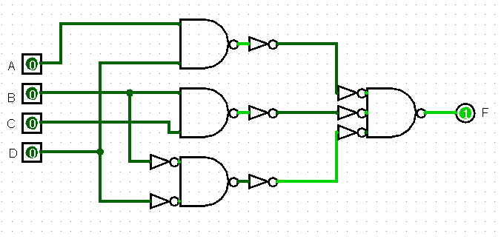

**Logic Circuit of F’ Function With NAND Gates**

